

Hale School

MATHEMATICS
SPECIALIST
3CD

Semester Two Examination 2011

MARKING KEY and SOLUTIONS

Section Two
Calculator-Assumed

Question 8 [7 marks]

The current I(t) amperes, in an electrical circuit, t milliseconds after a switch is turned on, obeys the differential equation :

amperes/millisecond

Initially there is no current flowing when the switch is turned on.

(a) Give the initial rate of change of the current when the switch is turned on.
[1]

Solution
At t = 0, I = 0 Hence

Specific Behaviours
Correct value using the derivative

(b) Using the separation of variables technique, determine the defining rule for I(t) in terms of t.
[4]

Solution
Hence -0.5 ln | 5 – 2I | = t + c
ln | 5 – 2I | = -2t + k

As 5 – 2I > 0, 5 – 2I = e^{-2t}. e^{k}
Using I(0) = 0, 5 - 2(0) = e⁰. e^{k,} Hence e^{k} = 5
5 - 2I = 5e^{-2t}
Gives I(t) = 2.5 – 2.5 e^{-2t}
Specific Behaviours
Separates variables correctly
Anti-differentiates correctly with an integration constant
Correct evaluation of integration constant
Obtains I(t) explicitly as a function of t

(c) Explain what is happening to the current after 1 second.
[2]
Solution
At t = 1000, I = 2.5 - 2.5 e⁻²⁰⁰⁰ = 2.5 amperes
Hence after 1 second, the current has reached its maximum value and is not changing.
Specific Behaviours
Correct t value, t = 1000
Comments that the current is not changing at all (reached some equilibrium)

Question 9 [8 marks]
A

The curve given by sin²(2x) = xy is shown.

(a) Find an expression for in terms of x and y using implicit differentiation.
[4]
Solution
Specific Behaviours
Derivative of sin²(2x)
Derivative of xy
Obtains dy/dx as the subject in terms of x and y

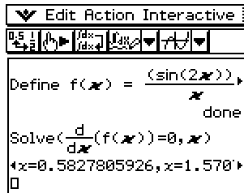
(b) Give the x co-ordinate for point A, the global maximum of the curve, correct to 0.01.
[2]

Solution
For global maximum require dy/dx = 0
From CAS x = 0.58 (2 d.p.)

Specific Behaviours
Condition for the global maximum
Value for x correct to 0.01

(c) Determine the slope of the curve as x 0.
[2]

Solution
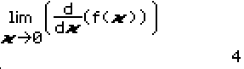
As x 0,
= 2(4) - 4
= 4
Hence the slope of the curve approaches 4 as x 0

Specific Behaviours
Use of the special trigonometric limit involving the sine function
Correct value

Question 10 [10 marks]
Using Calculus techniques, find the following indefinite integrals :
(a)
[2]
Solution
Specific Behaviours
Higher power and division by 3/2
Divide by 2 to undo the chain rule

(b)
[2]
Solution
Specific Behaviours
Natural logarithm anti-derivative using absolute value
Divide by 4 to undo the chain rule

(c)
[2]
Solution
Specific Behaviours
Recognise 4x is related to the derivative factor, so we can anti-differentiate
Correct answer

(d) Put u = x + 2
[4]
Solution
Specific Behaviours
Substitute for x and dx
Multiply out integrand in terms of u
Correct anti-derivative in terms of u
Express in terms of x
Question 11 [6 marks]

Using the method of proof by induction, prove that for all counting numbers n, the expression 3^{4n} - 1 is divisible by 80.

Solution
For n = 1 3⁴ - 1 = 80 True for n = 1
Assume true for n = k i.e. 3^{4k} - 1 = 80m for some integer m

Consider for n = k + 1 3^{4(k + 1)} - 1 = 3^{4k + 4} - 1
= 3^{4k} . 3⁴ - 1
= 81(80m + 1) - 1
= 81(80m) + 81 - 1
= 80(81m + 1)
This means that 3^{4(k + 1)} - 1 is divisible by 80.
Hence true for n = k + 1
Hence true for ALL values of n.

Specific Behaviours
Show true for n = 1
Assume true for n = k, using some multiple of 80
Consider expression for n = k + 1 (but not assuming it is divisible by 80)
Express 3^{4k + 4} in terms of the previous case
Algebraically show that this expression has a factor of 80
Explain that since true for n = k + 1 then true for ALL cases

Question 12 [8 marks]

A particle experiencing simple harmonic motion has a displacement of 10 cm when its velocity is cm s⁻¹ and when the particle is at its equilibrium position it has a velocity of 40 cm s⁻¹.

(a) Determine the period and amplitude of its motion.

[5]
Solution
Since SHM assume x(t) = A cos(nt)
Hence v(t) = - An sin(nt)

When x = 10, v = hence 10 = A cos (nt)
= - An sin(nt)

Using cos²(nt) + sin²(nt) = 1 then …… (1)
When x = 0, v = 40 hence 40 = - An ….. (2)

Solving gives A = 20
n = 2 Hence Period T = π seconds

Specific Behaviours
Knowledge of the form for x(t), v(t)
Writes an equation for x = 10
Writes equation for x = 0
Solves for A, n
Deduces the period T

(b) Determine the distance travelled by the particle, correct to the nearest 0.1 cm, over any period of time equal to seconds.
[3]

Solution
Period of motion T = π seconds
Hence time period represents 4.5 cycles of motion.

Distance travelled = 4.5 (4A) (1 cycle involves 4A distance)
= 18A
= 18(20) cm
= 360 cm

Specific Behaviours
Recognises distance in one cycle = 4A
Writes expression for required distance
Calculates distance correctly

Question 13 [9 marks]

(a) Solve the equation z⁵ = 1 over the set of complex numbers, giving solutions in exact exponential form.

[3]
Solution
z⁵ = cis 0
Hence z = where k = 0, 1, 2, 3 or 4

Solutions are z = cis(2π/5), cis(4π/5), cis(6π/5), cis(8π/5), cis(2π)
i.e. z = cis(2π/5), cis(4π/5), cis(-4π/5), cis(-2π/5), 1

Hence z =

Specific Behaviours
Writes 5 solutions with the correct equally spaced arguments
Uses exponential form for solutions
Uses arguments with correct convention -π < Arg (z) ≤ π

(b) Prove that the sum of the complex roots to part (a) is zero.

[3]
Solution
Let z₁ = = w
The Sum of the roots = w + w² + w³ + w⁴ + w⁵
=
Since w is a solution then w⁵ = 1
So Sum of roots = = 0

Specific Behaviours
Writes roots in terms of the principal root
Applies sum of a geometric series
Uses w⁵ = 1 idea

c) Hence, or otherwise, solve exactly the equation z⁷ + z⁵ - z² - 1 = 0.
[3]
Solution
Solve z⁵(z² + 1) - (z² + 1) = 0
(z² + 1)(z⁵ – 1) = 0
So z² + 1 = 0 or z⁵ - 1 = 0
Hence z = i, - i or
Specific Behaviours
Factorises correctly and applies Null Factor Theorem
Solves z² + 1 = 0 correctly (in any complex form)
Uses solutions from part (b)

Question 14 [10 marks]

Consider the functions f(x) = x^{n} and g(x) =
and the area trapped between these curves.

The graph shown below shows the case
where n = 3 i.e. f(x) = x³

(a) Using Calculus, determine the exact area between the curves for the case when n = 3.
[4]
Solution
Intersect when x = 0, x = 1 for all values of n > 0
Area = = =

Specific Behaviours
Intersects at x = 0, x = 1
Expression for exact area
Anti-derivative correct
Correct value

(b) If the exact area between the curves is square units, determine the value of n.
[4]
Solution
Intersect when x = 0, x = 1 for all values of n > 0
Area = = =
Hence
Solving gives n = 7.5
Specific Behaviours
Writes definite integral expression for area
Correct anti-derivative in terms of n
Writes equation to solve for n
Correct value of n

(c) If we consider an extremely high power for n, explain what happens to the area between the two curves.
[2]
Solution
Consider n ∞, A(n) 2/3
The area becomes a constant value of two-thirds, which is the area under the graph of
the square root function.
Specific Behaviours
Consider n increasing without bound
States the area becomes a constant value of 2/3

Question 15 [10 marks]

A co-ordinate system is defined showing the positive co-ordinate axes with O being the origin. Two part time rock-climbers Des Duller and Kev Krudder are each attached to two straight wires that allow them to slide down within a wide canyon.

At exactly 0930 hours, Des is at a position of -250i + 350j + 700k metres and is sliding down his wire with velocity 2.5i – j – k metres per second. Meanwhile Kev is stationary at a position 500i – 200j + 800k metres admiring the view. At exactly 0935 hours, Kev begins to slide down his wire at a velocity of -0.5i + j – 1.5k metres per second.
D
K
z
x
y

O

(a) What is Kev’s speed (correct to the nearest 0.01 m/sec) as he slides down his wire ?
[1]
Solution

v_{k} = -0.5i + j – 1.5k
Kev’s speed is 1.87 m/sec (2 d.p.)

Specific Behaviours
Gives the correct speed to 0.01 m/sec

(b) At what angle to the horizontal plane does Kev slide down, correct to the nearest degree ?
[2]
Solution
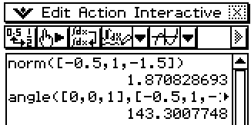
Horizontal plane normal vector n = 0i + 0j + 1k
Angle between n and v_{k} : θ = 143º
Hence angle Kev’s slide and the plane is
90 – θ i.e. -53º
Kev’s slides down at an angle of 53º to the horizontal

Specific Behaviours
Uses the plane normal vector to determine an angle
Gives the correct angle

Question 15 [contd.]

(c) It is known that Des and Kev do not collide. Determine the distance of their closest approach (correct to the nearest metre) and when this occurs (correct to the nearest second).
[3]

Solution
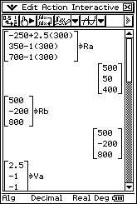
At 0935 Des is at r_{D} =
Closest approach when _{D}r_{K} . _{D}v_{K} = 0

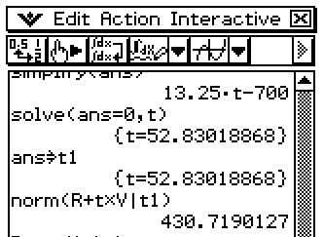
13.25t - 700 = 0
t = 52.83… sec after 0935 hrs

Hence they are closest at 0935 and 53 seconds.
Closest approach is 431 metres.
Specific Behaviours
Finds position for Des at 0935 hrs
Gives time for closest approach to nearest second
Gives closest approach to nearest metre

(d) If Kev was able to select both the speed and the time at which he commenced sliding down his wire, determine the distance, correct to the nearest metre, he would be able to get closest to Des ?

Explain showing your method.
[4]

Solution
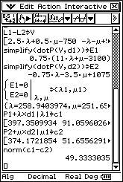
The question is equivalent to finding the closest approach of
one line in space to the other line. Equation for each line
(using independent parameters) :

r_{D} = r_{K} =

From CAS Closest approach is 49 metres if Kev can adjust
his starting position and speed.

Specific Behaviours
Explains closest approach between 2 lines in space
Uses velocities as direction vectors for each equation
Uses independent parameters for the lines
Closest approach correct to nearest metre

Question 16 [12 marks]

A small girl G is riding on a merry-go-round and her mother is watching from a fixed position at point M that is 5 metres from the merry go-round. The merry-go-round rotates at a speed of 1 revolution every 10 seconds in an anti-clockwise direction.
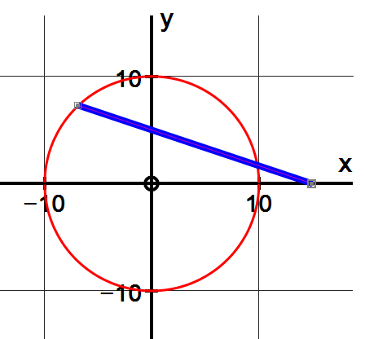

G

M

Let G have co-ordinates (x, y) at any time t seconds after the start. Assume that the girl begins the merry-go-round ride at (10, 0), the closest position to the mother.

(a) Given that we can use parametric equations for the position of the point G in the form of :
x = a cos bt (metres)
y = a sin bt
Explain why a = 10 and b = .
[2]
Solution
Largest value of x and y is 10 since the radius of the merry-go-round is 10 metres, so
a = 10. 2π radians per 10 seconds = π/5 = b (angular speed in radians)
Specific Behaviours
Explains that a = radius of circle
Explains that b = angular speed in radians

(b) If the mother is directly east of the merry-go-round, at what rate, correct to the nearest cm/second, is the girl travelling in a westerly direction 3 seconds after the start of the ride ?
[3]
Solution
Speed in a westerly direction is given by dx/dt.
dx/dt = -10 sin (3π/5).(π/5) = -5.9756 … cm/sec
Hence the girl is travelling WEST at a rate of 5.98 m/sec after 3 seconds.
Specific Behaviours
Uses dx/dt to answer question
Differentiates correctly to find dx/dt
Gives answer correct to 2 d.p.

Question 16 (contd.)

The distance that the girl is from the mother will fluctuate during the merry-go-round ride.

We can define S(t) = the distance MG (distance between the girl from the mother)

(c) Express S(t) as a function of t.
[1]

Solution
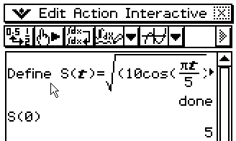
Girl is at (10cos πt/5, 10 sin πt/5), Mother is at (15,0)
S(t) =

Specific Behaviours
Uses distance formula correctly to express S(t)

(d) Determine the rate, correct to the nearest cm/second, at which the distance between the small girl and the mother is changing after 3 seconds.
[2]
Solution
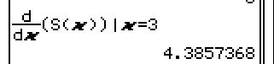
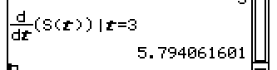
Using CAS : dS/dt = 5.79 m/sec
Hence the girl is moving away from the mother
at a rate of 4.39 m/sec.

Specific Behaviours
Recognises that the derivative S’(t) needs to be found.
Gives answer correct to 2 d.p.

(e) Determine when the small girl is moving away from the mother at the fastest rate, correct to the nearest 0.01 seconds.
[2]
Solution
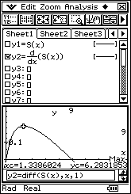
Small girl is moving away at the fastest rate when
S’(t) is a maximum.

Using CAS t = 1.34 seconds

Specific Behaviours
Recognises that the maximum for S’(t) needs to be found
Gives answer correct to 2 d.p.

Question 16 (contd.)

(f) How far is the small girl from the mother at the moment she is moving away from the mother at the fastest rate ?
[1]
Solution
Using CAS S(1.338….) = 11.180 ….

Hence when the small girl is moving away at the fastest rate, the girl is 11.18 m away.

Specific Behaviours
Gives answer correct to 2 d.p.

(g) Explain the geometric significance of the position of the small girl when she is moving away from the mother at the fastest rate.
[1]

Solution
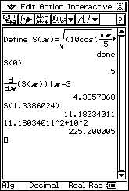
The small girl is moving away at the fastest rate from the mother, at the instant when the line segment connecting the mother to the girl is a TANGENT to the circle.

Note : MG² + 10² = 15²
[Right triangle dimensions]

Specific Behaviours
Explains that the MG is a tangent to the circle.

